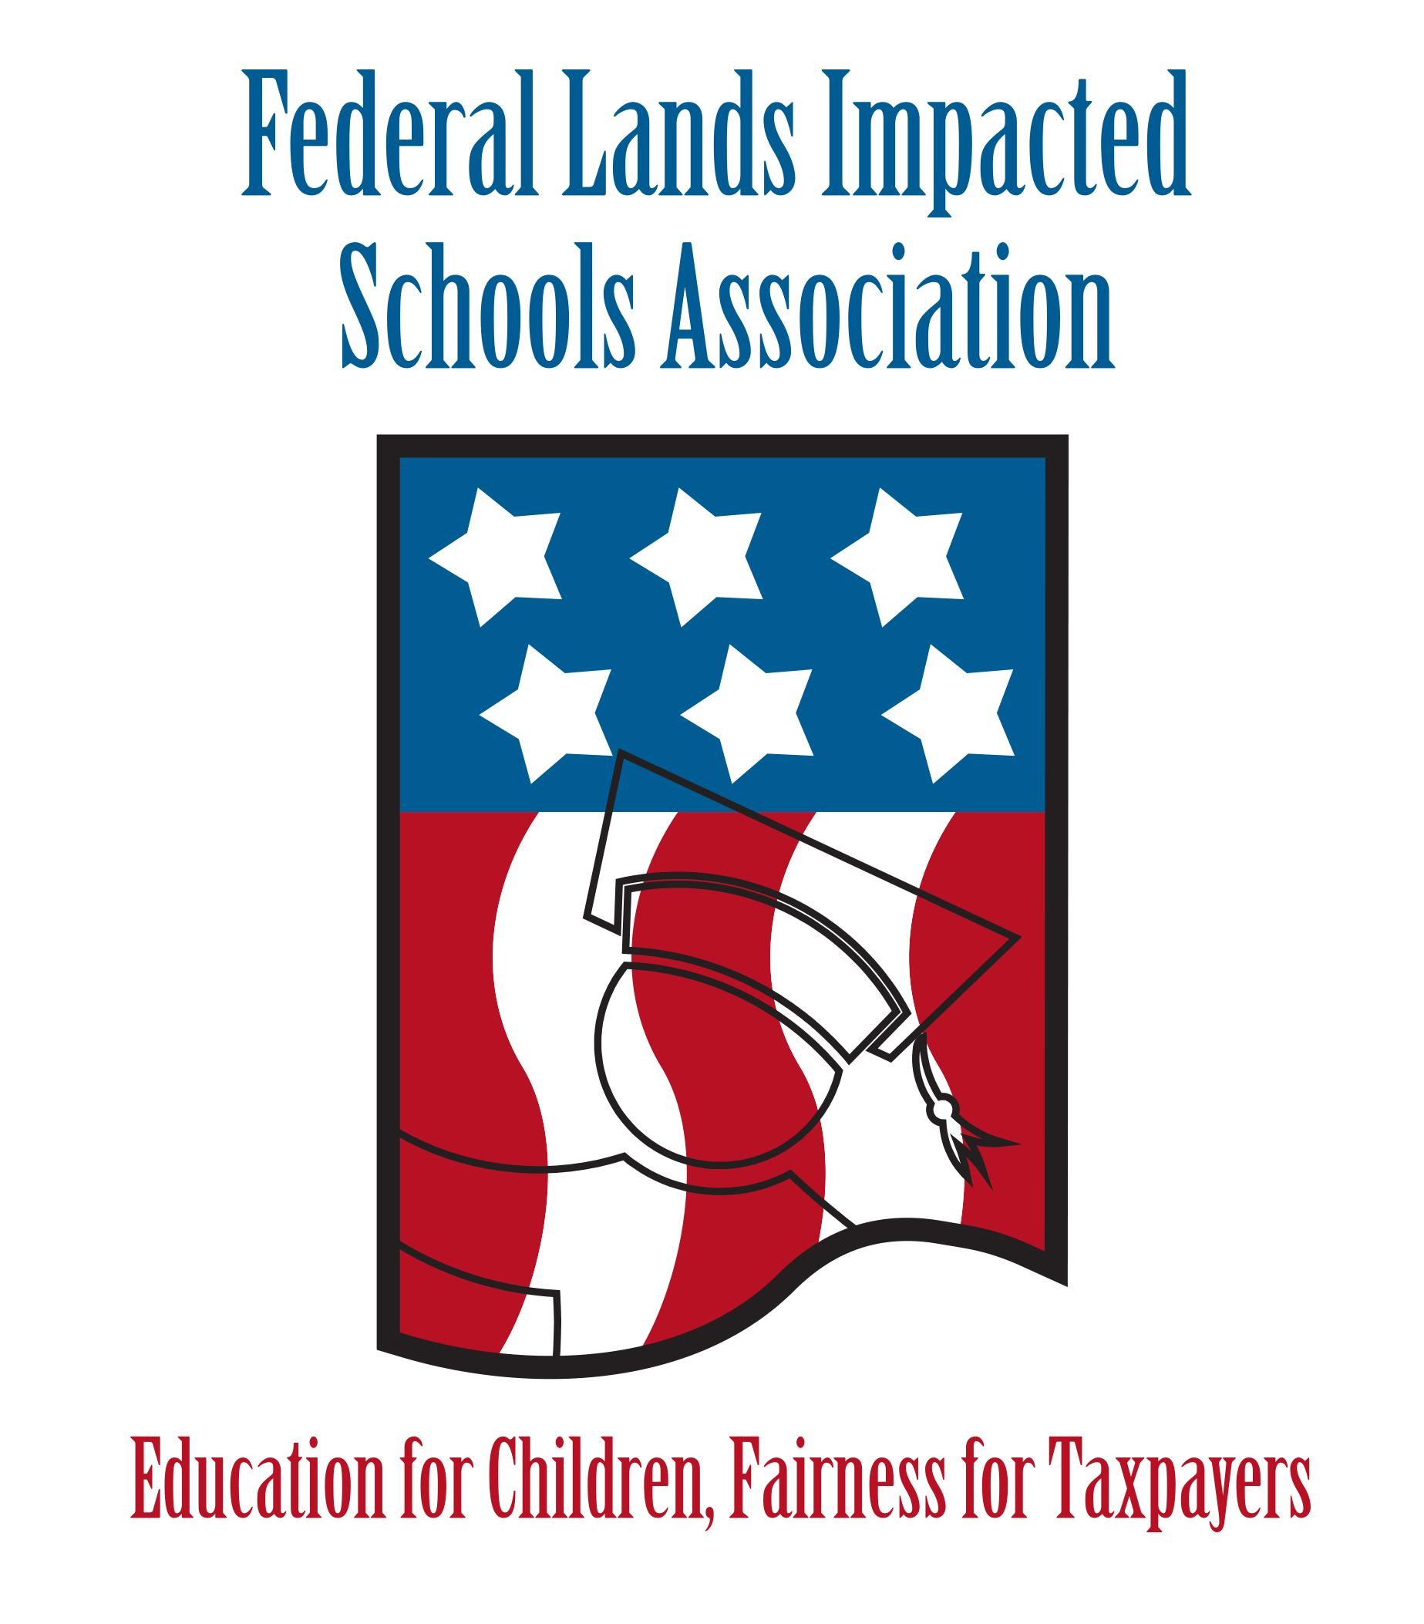Federal Lands Impacted

Schools Association

Education For Children, Fairness for Taxpayers

_________________________________________________________________

Protect your funding. Learn to Advocate. Be informed. Join FLISA.

***The Federal Lands Impacted Schools Association (FLISA) Mission***

* The Mission of National 7002 Impacted Schools is to secure federal funding which reimburses eligible districts for tax revenue lost due to the federal government’s removal of land from the local tax rolls; such revenue to be used for the public education of students.

***Reasons to join FLISA***

* Membership dues enable FLISA to advocate on Capitol Hill for public education and specifically the Federal Properties portion (section 7002) of the Impact Aid program. The new administration has identified the Federal Properties section as a target for elimination. Your membership, and advocacy efforts from other FLISA members and the NAFIS family, are critical for sustaining your District’s annual program funding.
* Your membership dollars help provide the resources FLISA needs to increase funding levels and move toward a fully funded program. Currently, section 7002 Federal Lands funding is funded approximately 7 cents on the dollar.
* You will have a say and vote when it comes to new initiatives, budgets, funding formula changes, etc.
* You will have access to resources necessary to keep fully up to date on the program and your district’s funding.
* Section 7002 Federal Properties is the smallest section of the Impact Aid program. We need to continue to grow our membership to have a strong voice for our districts.
* The law that provides for Impact aid funding gets re-authorized and updated periodically which includes proposed changes to the funding formula. Proposed updates are written by the 7002 members. Becoming a member and being involved protects your district’s funding and future financial interests.

***How to Become a Member of FLISA***

* School leaders looking to protect their Impact Aid Funding can join FLISA by completing our membership form sent annually or contacting the FLISA Executive Director, Tom Schneider directly at:

[schneiderthomasw@hotmail.com](mailto:schneiderthomasw@hotmail.com) or 219-545-1011. Information is also available on

our website: www.FLISA.org.